**Approach 1** – *My guess is something like this has already been done, but I’ll take a crack at it.* Using an overlay on the scene, a series of images are taken per second, and based on the location where the subject (A) is fast approaching, evaluation is done comparing the location across each marker(D), starting with the base marker at 0 miles, and incrementing by .019 miles/second (speed limit = B). Therefore, depending on the frame rate, which could be as little as 1 fps, the images can be

The challenges of such a design are numerous. For starters, how to calibrate the camera, so that the superimposed overlay matches the actual distance it’s interpreting. I guess it would be nice to normalize those values based on the cameras zoom level. Second, tracking the vehicle in multiple lanes. Third, what happens if another vehicle is tailgating and you can’t differentiate between the two objects? Obviously there needs to be some more intelligence and samples to

0 mi.

0 mph

70 mph

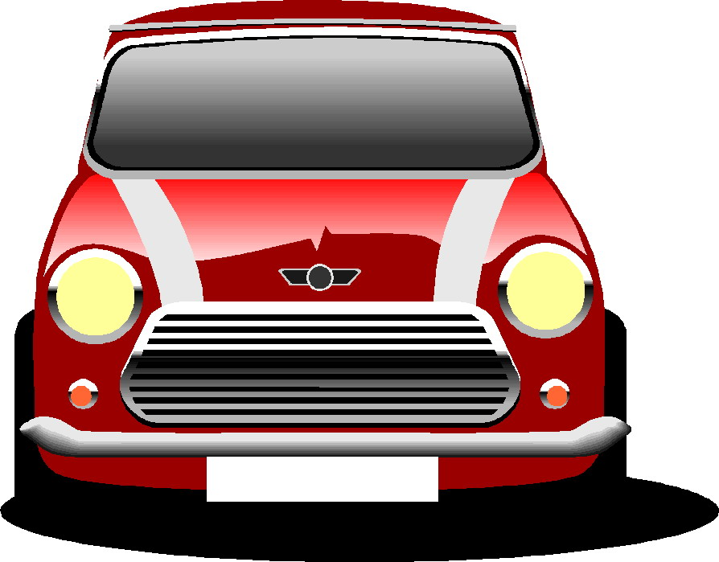

0 mi.

.019 mi.

.038 mi.

.057 mi.

.076 mi

0 mph

70 mph

**A**

**B**

**C**

**D**

0 mi.

0 mph

70 mph



0 mi.

0 mph

70 mph

0 mi.

72 mph

70 mph



Frame 1

Frame 2

Frame 3

Frame 4

Figure - Camera View. A) Subject B) Speed Limit C) Subjects Speed D)Markers

F2

F1

F3

F4

F5